**ORIGINAL INSTRUCTIONS**



**BELT SANDER**

**Mode: RS M6321-1**

RS M6321-1





**INSTRUCTION MANUAL**

LEROY-MERLIN

Rue Chanzy - Lezennes  
59712, Lille cedex 9  
France

**FOREWORD**

Thank you for purchasing this product. Read the instructions in this manual carefully. Proper use in accordance with these instructions will prevent accidents and extend the life of this tool.

This tool should not be modified and no part should be changed or altered by you, in relation to the standard specifications established by the manufacturer. Use this product for its intended purpose and as described in this manual. The user or operator of this tool is solely responsible for any malfunction resulting from improper or clumsy use and improper maintenance.

Since our manufacturing and products are constantly being optimized and improved, the specifications, descriptions, and illustrations in this manual may be subject to change (note that all descriptions and illustrations are accurate at the time of writing). We reserve the right to change technical specifications without notice to improve the performance of this tool. The user of this tool should therefore be aware that illustrations or descriptions may be slightly different from the actual product. Do not hesitate to ask for information from your dealer or our services if certain points do not seem clear to you.

**SUMMARY**

1. SAFETY WARNINGS...................................................................................
2. EXTRA SAFETY REGULATIONS CONCERNING BELT SANDER......................
3. EXPLANATION OF SYMBOLS .....................................................................
4. PART LIST...................................................................................................
5. TECHNICAL SPECIFICATION........................................................................
6. ASSEMBLY AND USE...................................................................................
7. SERVICE & MAINTENANCE.........................................................................
8. DISPOSAL....................................................................................................
9. EC DECLARATION OF CONFORMITY...........................................................
10. **SAFETY WARNINGS**

**General power tool safety warnings**

**WARNING Read all safety warnings, instructions, illustrations and specifications provided with this power tool.** *Failure to follow all instructions listed below may result in**electric shock, fire and/or serious injury*.

**Save all warnings and instructions for future reference.**

*The term "power tool" in the warnings refers to your mains-operated (corded) power tool or battery-operated (cordless) power tool.*

**1) Work area safety**

a) **Keep work area clean and well lit**. *Cluttered or dark areas invite accidents.*

b) **Do not operate power tools in explosive atmospheres, such as in the presence of flammable liquids, gases or dust.** *Power tools create sparks which may ignite the dust**or fumes.*

*c)* **Keep children and bystanders away while operating a power tool.** *Distractions can cause you to lose control.*

**2) Electrical safety**

a) **Power tool plugs must match the outlet. Never modify the plug in any way. Do not use any adapter plugs with earthed (grounded) power tools.** *Unmodified plugs and**matching outlets will reduce risk of electric shock.*

b) **Avoid body contact with earthed or grounded surfaces, such as pipes, radiators, ranges and refrigerators.** *There is an increased risk of electric shock if your body is**earthed or grounded.*

c) **Do not expose power tools to rain or wet conditions.** *Water entering a power tool will increase the risk of electric shock.*

d) **Do not abuse the cord. Never use the cord for carrying, pulling or unplugging the power tool. Keep cord away from heat, oil, sharp edges or moving parts.** *Damaged*

*or entangled cords increase the risk of electric shock.*

e) **When operating a power tool outdoors, use an extension cord suitable for outdoor use.** *Use of a cord suitable for outdoor use reduces the risk of electric shock.*

f) **If operating a power tool in a damp location is unavoidable, use a residual current device (RCD) protected supply.** *Use of an RCD reduces the risk of electric shock.*

NOTE The term “residual current device (RCD)” can be replaced by the term “ground fault circuit interrupter (GFCI)” or “earth leakage circuit breaker (ELCB)”.

**3) Personal safety**

a) **Stay alert, watch what you are doing and use common sense when operating a power tool. Do not use a power tool while you are tired or under the influence of drugs, alcohol or medication.** *A moment of inattention while operating power tools**may result in serious personal injury.*

b) **Use personal protective equipment. Always wear eye protection.** *Protective equipment such as a dust mask, non-skid safety shoes, hard hat or hearing protection used for appropriate conditions will reduce personal injuries.*

c) **Prevent unintentional starting. Ensure the switch is in the off-position before connecting to power source and/or battery pack, picking up or carrying the tool.**

*Carrying power tools with your finger on the switch or energising power tools that have the switch on invites accidents.*

d) **Remove any adjusting key or wrench before turning the power tool on.** *A wrench or a key left attached to a rotating part of the power tool may result in personal injury.*

e) **Do not overreach. Keep proper footing and balance at all times.** *This enables better control of the power tool in unexpected situations.*

f) **Dress properly. Do not wear loose clothing or jewellery. Keep your hair and clothing away from moving parts.** *Loose clothes, jewellery or long hair can be caught**in moving parts.*

g) **If devices are provided for the connection of dust extraction and collection facilities, ensure these are connected and properly used.** *Use of dust collection can**reduce dust-related hazards*.

h) **Do not let familiarity gained from frequent use of tools allow you to become complacent and ignore tool safety principles.** *A careless action can cause severe**injury within a fraction of a second.*

**4) Power tool use and care**

a) **Do not force the power tool. Use the correct power tool for your application.** *The correct power tool will do the job better and safer at the rate for which it was designed.*

b) **Do not use the power tool if the switch does not turn it on and off.** *Any power tool that cannot be controlled with the switch is dangerous and must be repaired.*

c) **Disconnect the plug from the power source and/or remove the battery pack, if detachable, from the power tool before making any adjustments, changing accessories, or storing power tools.** *Such preventive safety measures reduce the**risk of starting the power tool accidentally.*

d) **Store idle power tools out of the reach of children and do not allow persons unfamiliar with the power tool or these instructions to operate the power tool.** *Power tools are dangerous in the hands of untrained users.*

e) **Maintain power tools and accessories. Check for misalignment or binding of moving parts, breakage of parts and any other condition that may affect the power tool’s operation. If damaged, have the power tool repaired before use.**

*Many accidents are caused by poorly maintained power tools.*

f) **Keep cutting tools sharp and clean.** *Properly maintained cutting tools with sharp cutting edges are less likely to bind and are easier to control.*

g) **Use the power tool, accessories and tool bits etc. in accordance with these instructions, taking into account the working conditions and the work to be performed.** *Use of the power tool for operations different from those intended could**result in a hazardous situation.*

h) **Keep handles and grasping surfaces dry, clean and free from oil and grease.** *Slippery handles and grasping surfaces do not allow for safe handling and control of the**tool in unexpected situations.*

**5) Service**

a) **Have your power tool serviced by a qualified repair person using only identical replacement parts.** *This will ensure that the safety of the power tool is maintained.*

**Belt sander safety warnings**

**Hold the power tool by insulated gripping surfaces, because the sanding surface may contact its own cord.** *Cutting a "live" wire may make exposed metal parts of the power tool**"live" and could give the operator an electric shock.*

**WARNING** Contact with or inhalation of harmful / toxic dusts arising from sanding painted surfaces, woods and metals can endanger the health of operator and bystanders.

Take special care to guard against these dusts, including the following:

-All persons entering the work area must wear an approved mask specially designed for protection against harmful / toxic dusts, in addition to using the dust extraction facility, and keeping work area well ventilated.

- Children and pregnant women must not enter the work area.

- Do not eat, drink or smoke in the work area.

* Any pre 1960 building may have paint containing lead on wood or metal surfaces. If you suspect workpiece contains lead seek professional advice.
* Some wood and wood type products especially MDF (Medium Density Fibreboard) can produce dust that can be hazardous to your health. We recommend the use of an approved face mask with replaceable filters when using this machine in addition to using the dust extraction facility.
* Hold the machine correctly using two hands and adopt a stable stance, make sure that the mains cable is prevented from coming into contact with the machine or getting caught up on other objects preventing completion of the sanding pass.
* This tool is intended to remove surface material using an abrasive medium.
* Ensure that you have removed foreign objects such as nails and screws from the workpiece before commencing sanding.
* Do not use it for wet sanding, for dry sanding only.
* Where possible, secure smaller workpieces to prevent them from moving under the sander.
* Do not force the sander, let the tool do the work at a reasonable speed. Overloading will occur if too much pressure is applied and the motor slows resulting in inefficient sanding and possible damage to the sander motor.
* Do not use the dust collection box when sanding metal. The hot metal particles could cause residual wood dust or the internal filter paper to catch fire.
* Do not continue to use worn, torn or heavily clogged sanding belts.
* Do not touch the moving sanding belt.
* If the replacement of the supply cord is necessary, this has to be done by the manufacturer or his agent in order to avoid a safety hazard;

1. **EXPLANATION OF SYMBOLS**

In this manual and/or on the machine the following symbols are may used:

|  |  |
| --- | --- |
|  | Read instructions carefully |
|  | In accordance with essential applicable safety standards of European directives |
|  | Class II machine – Double insulation – You don’t need any earthed plug. |
|  | Faulty and/or discarded electrical or electronic apparatus have to be collected at the appropriate recycling locations |
|  | Wear eye protection |
|  | Wear respiratory protection |

1. **PART LIST**

##### 

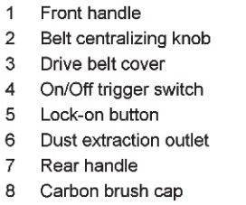

##### Technical specification

|  |  |
| --- | --- |
| Type designation | Belt Sander |
| Rated voltage | 230V~ 50Hz |
| Rated power input | 1200W |
| Speed, n0 | 480m/min |
| Sanding belt size | 100 x 610mm |
| Level of acoustic pressure LpA (KpA=3dB(A)) | 86 dB(A) |
| Level of acoustic power LwA (KwA=3dB(A)) | 97 dB(A) |
| Level of vibration ah (K=1.5m/s2 ) | 2.21m/s2 |
| Protection class | II |

Information:

* The declared vibration total value has been measured in accordance with a standard test method and may be used for comparing one tool with another;
* The declared vibration total value may also be used in a preliminary assessment of exposure.

Warning:

* that the vibration emission during actual use of the power tool can differ from the declared total value depending on the ways in which the tool is used; and
* of the need to identify safety measures to protect the operator that are based on an estimation of exposure in the actual conditions of use (taking account of all parts of the operating cycle such as the times when the tool is switched off and when it is running idle in addition to the trigger time).

Wear hearing protection.

1. **ASSEMBLY AND USE**

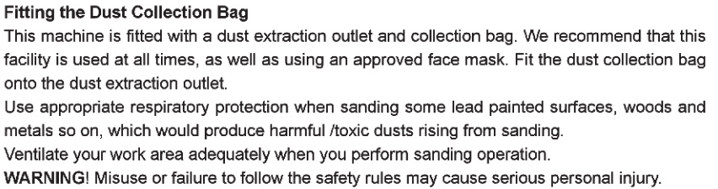**Selecting the right grade of sanding belt**

Different grades of sanding belt can be purchased from the store where you purchased the tool. Available grades are: Coarse, Medium and Fine.

Use a coarse grit to sand down rough finishes, medium grit to smooth the work and fine grit to finish off.

It is best to make a trial run on a scrap piece of material to determine the optimum grades of sanding belt for a particular job.

|  |  |  |
| --- | --- | --- |
| **GRIT CHART** | | |
| Grit | Type | Example of use |
| 60 or less | Very Coarse | Material removal, heavy paint removal, shaping wood |
| 80 – 100 | Coarse | Paint removal, rough surface preparation (e.g. non-planed wood) |
| 120 – 150 | Medium | Surface preparation planed wood |
| 180 – 220 | Fine | Sanding between coats |
| 240 or more | Very Fine | Final finishing |

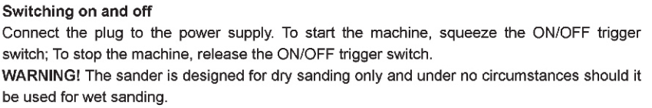

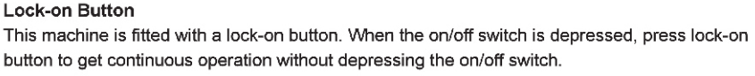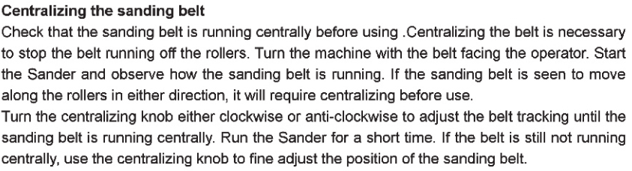

##### Adjust the working speed by turning the knob on the front handle. We recommend using a slow speed initially and then accelerating. The MIN marking is the slowest speed and the MAX marking is the fastest speed.

##### Sanding

The sander can be used for most sanding operations on materials such as wood, plastic, metal and painted surfaces.

**WARNING** : Don’t use this machine on plaster.

 Wear safety goggles and dust mask.

Where possible, secure smaller workpiece to prevent them from moving under the sander. Lower the sander in contact with the workpiece without pressure and then start the sander.

Move the sander slowly over the surface of the workpiece, for best results use the sander in a linear motion not circular. Using the sander in a circular motion may result in the belt tracking slipping. Sand with the grain, in parallel over lapping strokes.

To remove paint or smooth very rough wood, sand across the grain at 45º in two directions, and then finish parallel with the grain. Use the front roller only to sand corners or irregular shapes.

Lift the sander off the work before switching off. Remember to keep your hands away from the moving belt, as it will continue to move for a short time after the machine is switched off.

If there are still scratches on your work after sanding, try either of the following:

-Go back to a coarser grit and sand the marks out before recommencing with the original choice or,

-Try using new sanding belt of the same grit to eliminate the unwanted marks before progressing to a finer grit and finishing the job.

1. **SERVICE & MAINTENANCE**

Always disconnect the device before performing any adjustment or maintenance operation. If the supply cord is damaged, it must be replaced by the manufacturer or its service agent in order to avoid a hazard.

Disconnect from the power supply immediately if the supply cord is damaged. Take care not to expose this tool to the rain.

If the carbon brushes need to be replaced, have this done by a qualified repair person (always replace the two brushes at the same time)

**Cleaning**

Avoid using solvents when cleaning plastic parts. Most plastic parts are susceptible to damage from various types of commercial solvents and may be damaged by their use. Use clean cloths to remove dirt, carbon dust, etc.

**Lubrication**

All the bearings in this tool are lubricated with a sufficient amount of high grade lubricant for the life of the unit under normal operating conditions, therefore no further lubrication is required.

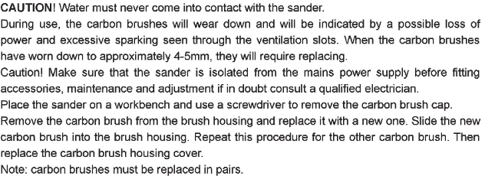

Exploded drawing

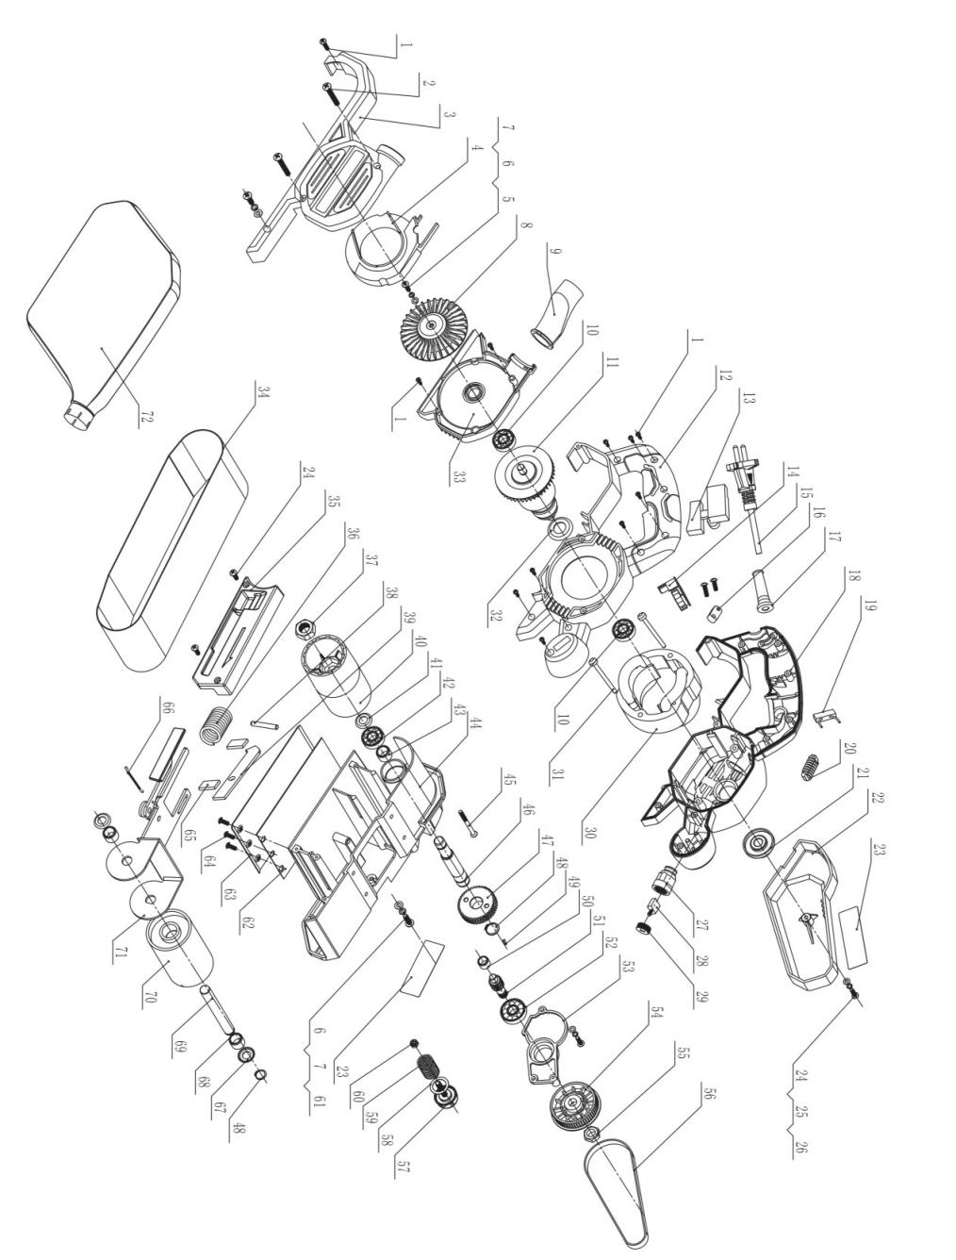

1. **DISPOSAL**

CAUTION! This product has been marked with a symbol relating to removing electric and electronic waste. This means that this product shall not be discarded with household waste but that it shall be returned to a collection system which conforms to the European WEEE Directive. Contact your local authorities or ask for advice on recycling. It will then be recycled or dismantled in order to reduce the impact on the environment. Electric and electronic equipment can be hazardous for the environment and for human health since they contain hazardous substances.

1. **EC DECLARATION OF CONFORMITY**

|  |  |
| --- | --- |
| |  | | --- | | **EC declaration of conformity** | |

I, Gislain Menard, acting as Quality Director, authorized to create the technical file, on behalf of the company Leroy Merlin France whose head office is located, Rue Chanzy-Lezennes, 59712 Lille Cedex 9, France, declares:

Products: BELT SANDER

Model: RS M6321-1

Serial number: 20190527740-20190528239

Developed, designed and manufactured in accordance with the requirements of directives:

Machinery Directive 2006/42/EC, EMC Directive 2014/30/EC, ROHS Directive 2011/65/EU

Also meets the following standards:

EN 62841-1:2015+AC:15

EN62841-2-4:2014+AC:15

EN55014-1:2017

EN55014-2:2015

EN61000-3-2:2014

EN61000-3-3:2013

EN 62321:2009

Done at Lezennes on 15/04/2019

GISLAIN MENARD, Quality Director